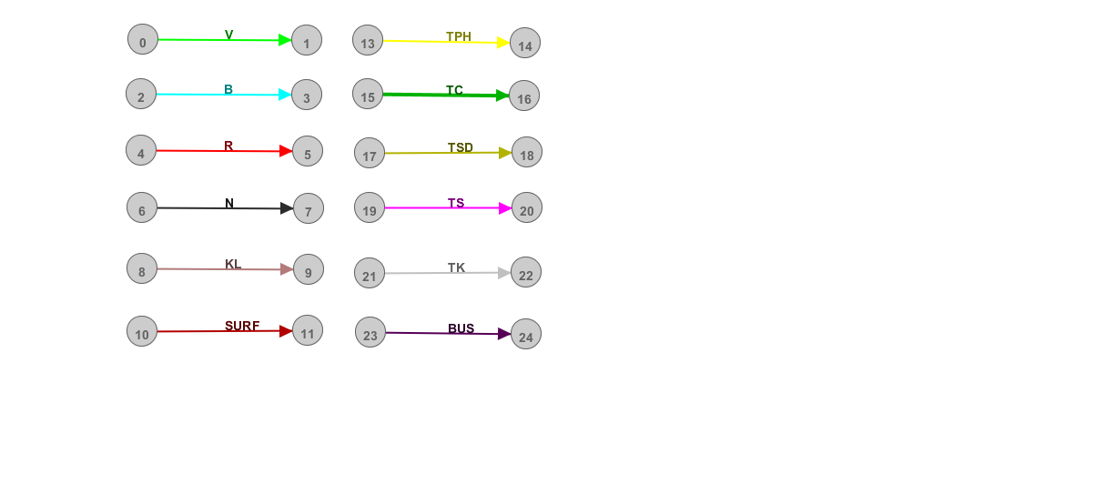

Legend :

villaroger2(B)

Marmottes(B)

plan-des-eaux(B)

soliet3(R)

soliet2(R)

soliet1(R)

grand-col(R)

reservoir(R)

